Name : Haroon Ali Imran

Roll : 22024119-027

Section : BSCS-A

**Project Title : Town Management (Smart City)**

**Introduction**

This database project involves the creation and management of a comprehensive database named Town_Mangement for a fictional town. The database is designed to manage information about citizens, services provided, service requests, employees, departments, and resources. The main objective is to streamline town management by efficiently storing and retrieving relevant data. The database is built using SQL and includes several tables, procedures, and sample data to demonstrate its functionality.

**Database Schema**

1. **Database Creation and Usage**
   * The database Town_Mangement is created and selected for use.
2. **Tables**
   * **Citizens**: Stores information about the citizens of the town.
   * **Services**: Contains details about various services provided by the town.
   * **Service_Requests**: Records requests made by citizens for services.
   * **Employees**: Contains information about town employees.
   * **Departments**: Stores details of different departments in the town administration.
   * **Resources**: Manages the town's resources and their locations.
3. **Stored Procedures**
   * Procedures to insert data into the Citizens, Services, Service_Requests, Employees, Departments, and Resources tables.
   * Procedures to retrieve all records from the Citizens, Services, and Service_Requests tables.
4. **Sample Data**
   * Insert sample records into the Citizens, Services, Service_Requests, Employees, Departments, and Resources tables.

**Entity-Relationship Diagram (ERD)**

The following ERD represents the schema of the Town_Mangement database. It includes the relationships between the various tables such as Citizens, Services, Service_Requests, Employees, Departments, and Resources.

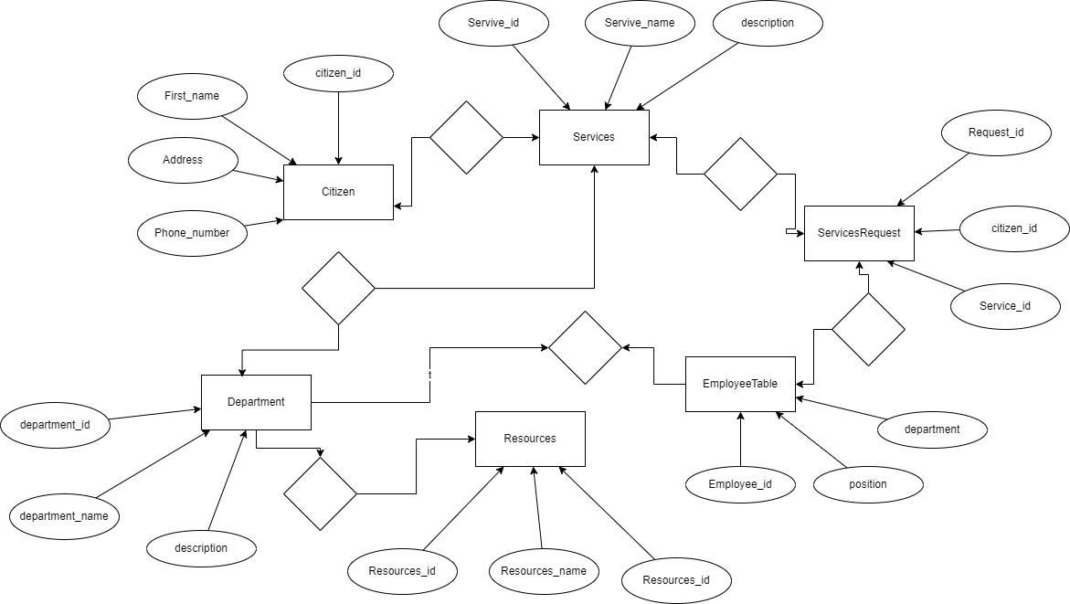

**SQL Code**

create database Town_Mangement;

use Town_Mangement;

drop database Town_Mangement;

CREATE TABLE Citizens (

citizen_id INT PRIMARY KEY AUTO_INCREMENT,

first_name VARCHAR(50),

last_name VARCHAR(50),

email VARCHAR(100),

phone VARCHAR(15),

address VARCHAR(200),

date_of_birth DATE

);

CREATE TABLE Services (

service_id INT PRIMARY KEY AUTO_INCREMENT,

service_name VARCHAR(100),

description TEXT,

category VARCHAR(50)

);

CREATE TABLE Service_Requests (

request_id INT PRIMARY KEY AUTO_INCREMENT,

citizen_id INT,

service_id INT ,

request_date DATE,

status VARCHAR(50),

FOREIGN KEY (citizen_id) REFERENCES Citizens(citizen_id),

FOREIGN KEY (service_id) REFERENCES Services(service_id)

);

drop table Service_Requests;

CREATE TABLE Employees (

employee_id INT PRIMARY KEY AUTO_INCREMENT,

first_name VARCHAR(50),

last_name VARCHAR(50),

position VARCHAR(50),

department VARCHAR(50)

);

CREATE TABLE Departments (

department_id INT PRIMARY KEY AUTO_INCREMENT,

department_name VARCHAR(100),

description TEXT

);

CREATE TABLE Resources (

resource_id INT PRIMARY KEY AUTO_INCREMENT,

resource_name VARCHAR(100),

quantity INT,

location VARCHAR(100)

);

DELIMITER //

CREATE PROCEDURE InsertCitizen (

IN first_name VARCHAR(50),

IN last_name VARCHAR(50),

IN email VARCHAR(100),

IN phone VARCHAR(15),

IN address VARCHAR(200),

IN date_of_birth DATE

)

BEGIN

INSERT INTO Citizens (first_name, last_name, email, phone, address, date_of_birth)

VALUES (first_name, last_name, email, phone, address, date_of_birth);

END //

DELIMITER ;

DELIMITER //

CREATE PROCEDURE InsertService (

IN service_name VARCHAR(100),

IN description TEXT,

IN category VARCHAR(50)

)

BEGIN

INSERT INTO Services (service_name, description, category)

VALUES (service_name, description, category);

END //

DELIMITER ;

DELIMITER //

CREATE PROCEDURE InsertServiceRequest (

IN citizen_id INT,

IN service_id INT,

IN request_date DATE,

IN status VARCHAR(50)

)

BEGIN

INSERT INTO Service_Requests (citizen_id, service_id, request_date, status)

VALUES (citizen_id, service_id, request_date, status);

END //

DELIMITER ;

DELIMITER //

CREATE PROCEDURE InsertEmployee (

IN first_name VARCHAR(50),

IN last_name VARCHAR(50),

IN position VARCHAR(50),

IN department VARCHAR(50)

)

BEGIN

INSERT INTO Employees (first_name, last_name, position, department)

VALUES (first_name, last_name, position, department);

END //

DELIMITER ;

DELIMITER //

CREATE PROCEDURE InsertDepartment (

IN department_name VARCHAR(100),

IN description TEXT

)

BEGIN

INSERT INTO Departments (department_name, description)

VALUES (department_name, description);

END //

DELIMITER ;

DELIMITER //

CREATE PROCEDURE InsertResource (

IN resource_name VARCHAR(100),

IN quantity INT,

IN location VARCHAR(100)

)

BEGIN

INSERT INTO Resources (resource_name, quantity, location)

VALUES (resource_name, quantity, location);

END //

DELIMITER ;

DELIMITER //

CREATE PROCEDURE GetAllCitizens()

BEGIN

SELECT * FROM Citizens;

END //

DELIMITER ;

DELIMITER //

CREATE PROCEDURE GetAllServices()

BEGIN

SELECT * FROM Services;

END //

DELIMITER ;

DELIMITER //

CREATE PROCEDURE GetAllServiceRequests()

BEGIN

SELECT * FROM Service_Requests;

END //

DELIMITER ;

-- Insert sample citizens

CALL InsertCitizen('Ali', 'Hamza', 'AliHamza@gmail.com', '+1234567890', '123 Elm Street', '1980-01-01');

CALL InsertCitizen('Ali', 'Haider', 'Ali@gmail.com', '+1234567891', '456 Oak Avenue', '1990-02-02');

-- Insert sample services

CALL InsertService('Garbage Collection', 'Weekly garbage collection service', 'Sanitation');

CALL InsertService('Water Supply', 'Daily water supply service', 'Utilities');

-- Insert sample service requests

CALL InsertServiceRequest(1, 1, '2024-06-01', 'Pending');

CALL InsertServiceRequest(2, 2, '2024-06-02', 'Completed');

-- Insert sample employees

CALL InsertEmployee('Ali', 'Brown', 'Manager', 'Sanitation');

CALL InsertEmployee('Haroon', 'White', 'Technician', 'Utilities');

-- Insert sample departments

CALL InsertDepartment('Sanitation', 'Handles waste management and recycling services');

CALL InsertDepartment('Utilities', 'Manages water, electricity, and other utilities');

-- Insert sample resources

CALL InsertResource('Truck', 5, 'Garage 1');

CALL InsertResource('Water Pump', 10, 'Storage Facility');

-- Verify citizens

SELECT * FROM Citizens;

-- Verify services

SELECT * FROM Services;

-- Verify service requests

SELECT * FROM Service_Requests;

-- Verify employees

SELECT * FROM Employees;

-- Verify departments

SELECT * FROM Departments;

-- Verify resources

SELECT * FROM Resources;